Keywords: Machine Learning, CFD, Temperature Prediction, Pin-Fin

## LITERATURE REVIEW

Kim et. al presented a machine learning model which predicts the heat transfer performance of a various pin-fin system. [1]

Lee et. al presented a multimodal machine learning approach that inter relates geometric features to predict heat transfer for a given fin. [2]

## NOMENCLATURE

|  |  |
| --- | --- |
| Wi | Weight matrix for layer i (dimensionless) |
| bi  xi | Bias vector for layer i (dimensionless)  Input value for the model (dimensionless) |
| ̂yi  yi  f(.)  MSE  MAE | Predicted temperature for the ith sample (K)  Ground truth temperature for the ith sample (K)  Activation function (dimensionless)  Mean square error  Mean absolute error |
| Greek Symbols | |
| η | Learning rate for the Adam optimizer |
|  |  |
| Subscripts | |
| src  tgt  i | Source  Target  Index for data sample or network layer |

## INTRODUCTION

Fin surfaces are widely used in heat dissipation processes. Though traditional research and development is going on to increase the efficiency of the fin, machine learning approach could be a good alternative to predict the heat transfer through the specific coordinates in 2d and 3d planes. Traditional systems rely on numerical analysis and finite volume analysis which are heavy computational tasks. Recently data driven approaches like Artificial Neural Networks (ANNs) gained popularity in the thermal field. In this system, we train the model with some input parameters along with targeted output, then we predict the output with some unknown data. We have taken △T(x, y, z1,2,…,6) as input parameters and then predicted the △T for other z planes.

## BODY OF THE PAPER

### Artificial Neural Network Model Architecture

## To predict temperature differences (∆T) at the unmeasured z-planes (z = 100 and z = 375), an artificial neural network (ANN) was trained using data from six known planes: z = 0, 175, 275, and 475 mm.

Fig. 1 shows the model structure for visualisation.

* + 1. Interpolation using IDW

To align the (x, y) coordinates across all 2d and 3d datasets, Inverse Distance Weighting (IDW) was applied using cKDTree for efficient neighbor search. For each target point, the temperature was interpolated from its 10 nearest neighbors, with weights inversely proportional to the square of the distance (p=2p = 2p=2). This provided a consistent temperature field over the Z = 0 plane, essential for ∆T computation.

* + 1. Temperature difference calculation

Temperature difference (ΔT) was computed with respect to the base plane (Z = 0):

This highlights the thermal variation across the z-direction and was used as the learning target for the ANN.

* + 1. ANN model for ∆T prediction

An ANN was trained to predict ∆T at deeper planes (z = 100, 375 mm) using known data from z = 0 to 475. The model used are as follows:

Input: Scaled (x, y) and ∆T using Standard Scaler

Layers: 64 → 128 → 64 neurons, with Relu activation and output layer with linear activation function

The model was trained using the Adam optimizer with gradient clipping (clipnorm = 1.0). Loss metrics used was given in eq. 6. Early stopping improved convergence and prevented overfitting and gradual decrease of validation loss.

## EQUATIONS

Euclidean distance is given by dji between jth and ith position

(1)

Wights for its k-nearest neighbour

(2)

Normalising the weights

(3)

Interpolation Ti at point j

(4)

Mean absolute error formula

(5)

Mean square error formula

(6)

Deep learning model equation is given as

(7)

ReLU activation function equation is

ReLU(x) = max(0, x) (8)

Peicewise Form:

## FIGURES

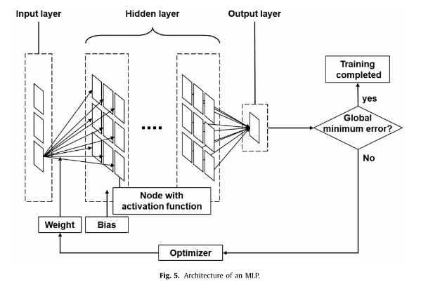

Fig 1. Structure of the ANN

Figure 1 shows the basic implementation structure of the Artificial Neural Network used along with labelled weights and biases and use of optimizer to automatically change the weights and biases to get the maximum accuracy with least error.

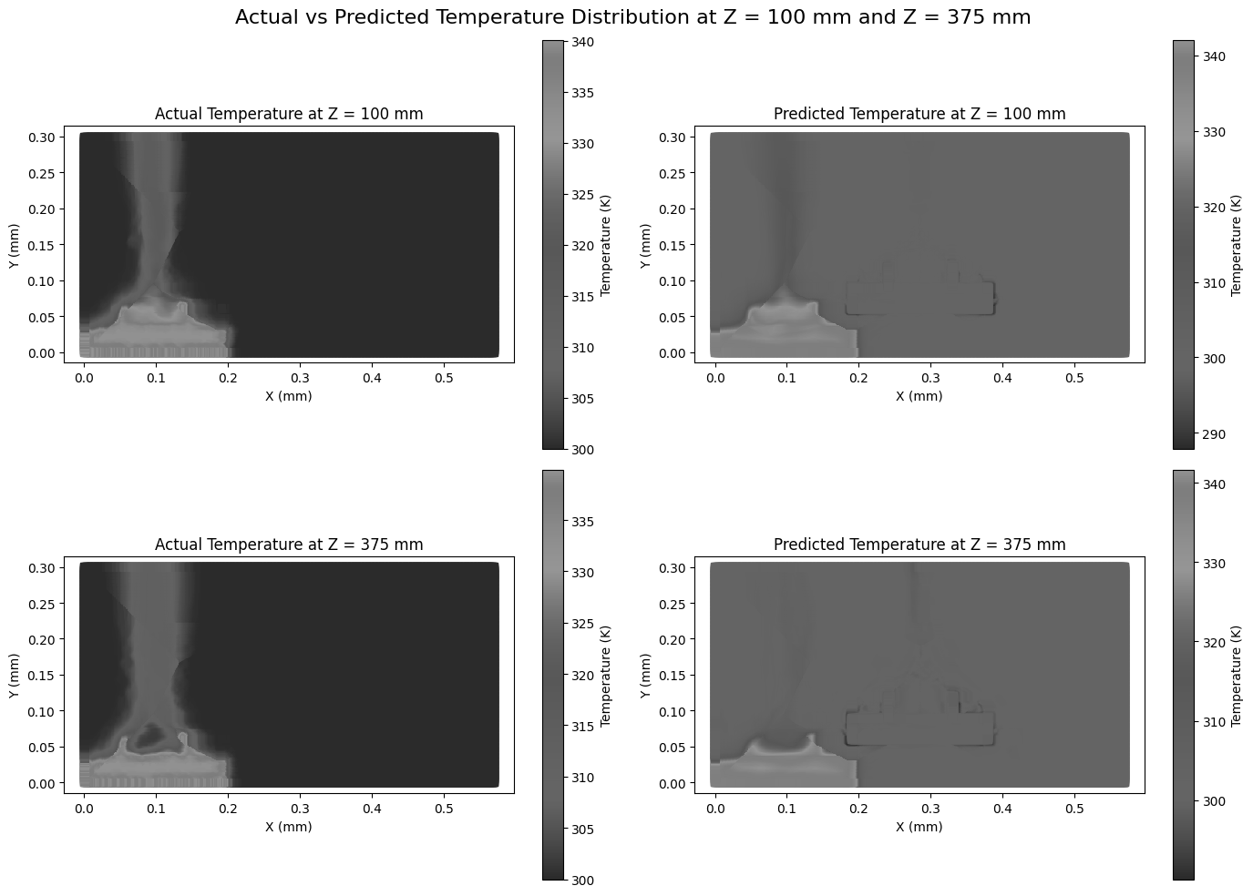

Fig 2. Actual temperature data plot of Z = 100 mm plane



Fig 3. Predicted temperature data plot of Z = 100 mm plane

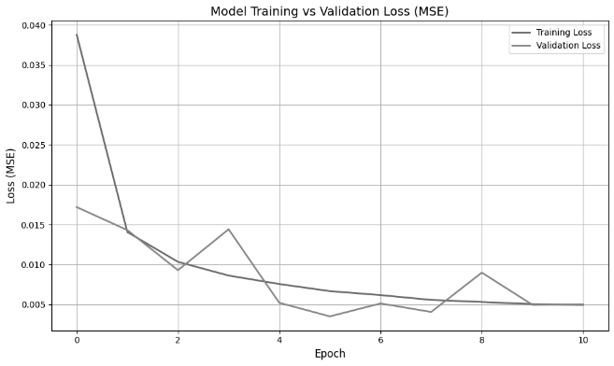

Fig 4. Comparison between Training Loss and Validation Loss

## RESULT

Scaled test MAE = 0.0225013904

Scaled test MSE = 0.0035041757

Real temperature MAE = 0.3117753691

## REFERENCES

Journals

[1] K Kim, H Lee, M Kang, G Lee, K Jung, C R Kharangate, M Asheghi, K E Goodson, H Lee, A machine learning approach for predicting heat transfer characteristics in micro-pin fin heat sinks, 2022, 194, 123087

[2] H Lee, G Lee, K Kim, D Kong, H Lee, Multimodal machine learning for predicting heat transfer characteristics in micro-pin fin heat sinks, 2024, 57, 104331